|  |
| --- |
|  |
| **BOOKAHOLIC**  **SOCIAL NETWORK** |

Report #6 – User Manuals

|  |  |
| --- | --- |
| **BOOKAHOLIC SOCIAL NETWORK** | |
| **Group Member** | SE03416 – Pham Thi Huyen |
| SE03380 – Vu Hai Dang |
| SE03409 – Thai Thi Cam Van |
| SE03171 – Nguyen Thi Hai Yen |
|  | SE03143 – Chu Minh Hai |
| **Supervisor** | Nguyen Van Sang |
| **Ext. Supervisor** |  |
| **Project Code** | BSN |

**- Hanoi, 12/2016 -**

# SIGNATURE PAGE

AUTHOR: Nguyen Thi Hai Yen 12/12/2016

Team member

REVIEWERS: Pham Thi Huyen 12/12/2016

Project manager

APPROVAL: Nguyễn Văn Sang --/--/--16

Supervisor

Record of change

*A - Added M - Modified D – Deleted

|  |  |  |  |  |  |
| --- | --- | --- | --- | --- | --- |
| Effective Date | Changed Item | A,M,D | Change Description | Reason for Change | Rev. Number |
| 12/12/2016 | User installation | A | Add new |  | 1.0 |
| 12/12/2016 | User guide | A | Add new |  | 1.0 |
|  |  |  |  |  |  |
|  |  |  |  |  |  |
|  |  |  |  |  |  |
|  |  |  |  |  |  |
|  |  |  |  |  |  |
|  |  |  |  |  |  |
|  |  |  |  |  |  |
|  |  |  |  |  |  |
|  |  |  |  |  |  |
|  |  |  |  |  |  |
|  |  |  |  |  |  |
|  |  |  |  |  |  |
|  |  |  |  |  |  |
|  |  |  |  |  |  |
|  |  |  |  |  |  |

Table of Contents

SIGNATURE PAGE 1

Introduction 3

1.1 Purpose 3

1.2 Environment 3

1.3 Application Installations 3

2 USER GUIDELINES 4

2.1 Account 4

2.2 Recommendation 6

2.3 Comment 10

2.4 Group 11

2.5 Book 19

2.6 Interaction 20

2.7 ADMIN 23

# Introduction

## Purpose

This document contains guide-lines step by step to use BSN website, and set up its own database.

## Environment

Following are the software required to start the FAP system:

* Operating System: Windows 7, Windows 8
* Browsers: Firefox 40, Chrome 44 or higher.
* Database:
* .NET Framework 4.5

# USER GUIDELINES

## Account

### Register for a normal and an author

This is the first page which user will see. From this page the user can go to every page they want.

To register account on website, the users do the steps below:

Step 1: Open browser and enter to the address bar: <http://bookaholic.com/>. Register – Login page is displayed.

Step 2: Enter information on register form

Step 3: Click “Đăng ký” button to login BSN website



Figure .: Register - Login screen

### Login

To login account on website, the users do the steps below:

Step 1: Open browser and enter to the address bar: <http://bookaholic.com/> Register – Login page is displayed.

Step 2: Enter information (Email, Password)

Step 3: Click “Đăng nhập” button



Figure .: Login page

### Reset password

In case the user forgot password, the users do the steps below:

Step 1: Click “Bạn không đăng nhập được?” below “Mật khẩu” textbox

Step 3: Input email on textbox

Step 4: Click “Gửi” button

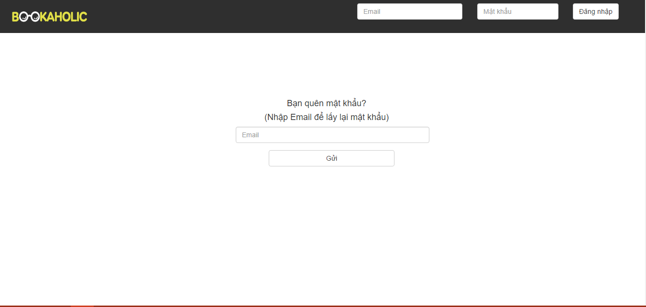

Figure .: Reset password

### Edit personal information

Users to edit personal information includes name, email, address, date of birth., the users do the steps below:

Step 1: User logged in BSN website

Step 2: Click “Chỉnh sửa thông tin” hyperlink while in home page

Step 3: Modifies fields

Step 4: Click “Lưu” button

At the step 2:

Display Edit profile page includes:

* Navigation bar
* User profile panel
* Side bars

User’s information

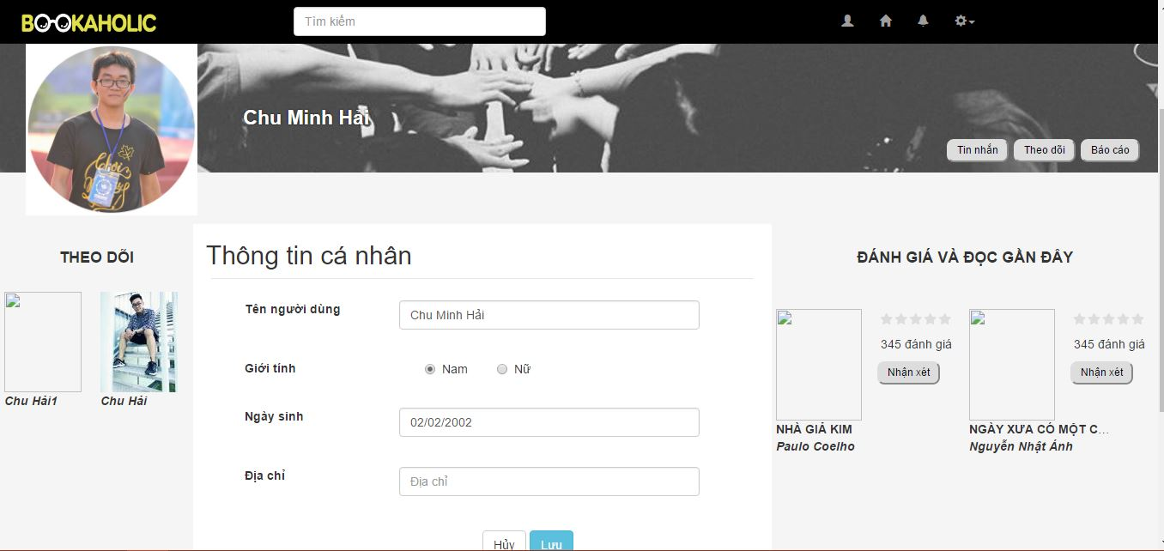

Figure .: Edit personal information

### Edit avatar and cover photo

Users to edit their avatar and cover photo, the users do the steps below:

Step 1: User logged in BSN website

Step 2: At the home page or personal page

Click icon camera on the avatar or cover

Step 3: Choose avatar photo or cover photo

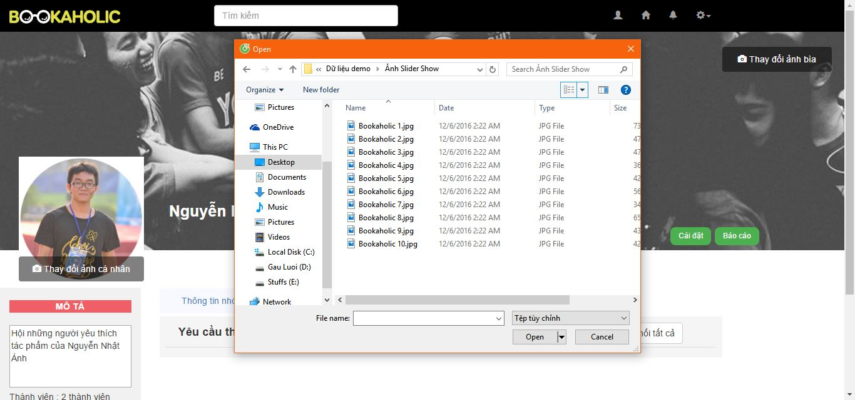

Figure .: Edit avatar and cover photo

## Post

### Create a post

To users (includes Reader and Author) post a recommendation, the users do the steps below:

Step 1: User logged in BSN website

Step 2: Enter Home page or Personal page

Step 3: Click “Bạn đang nghĩ gì” text area and enter a recommendation

Step 4: Click “Nhập thẻ sách” input and enter book’s name or author’s name

Step 5: Click “Đăng” button

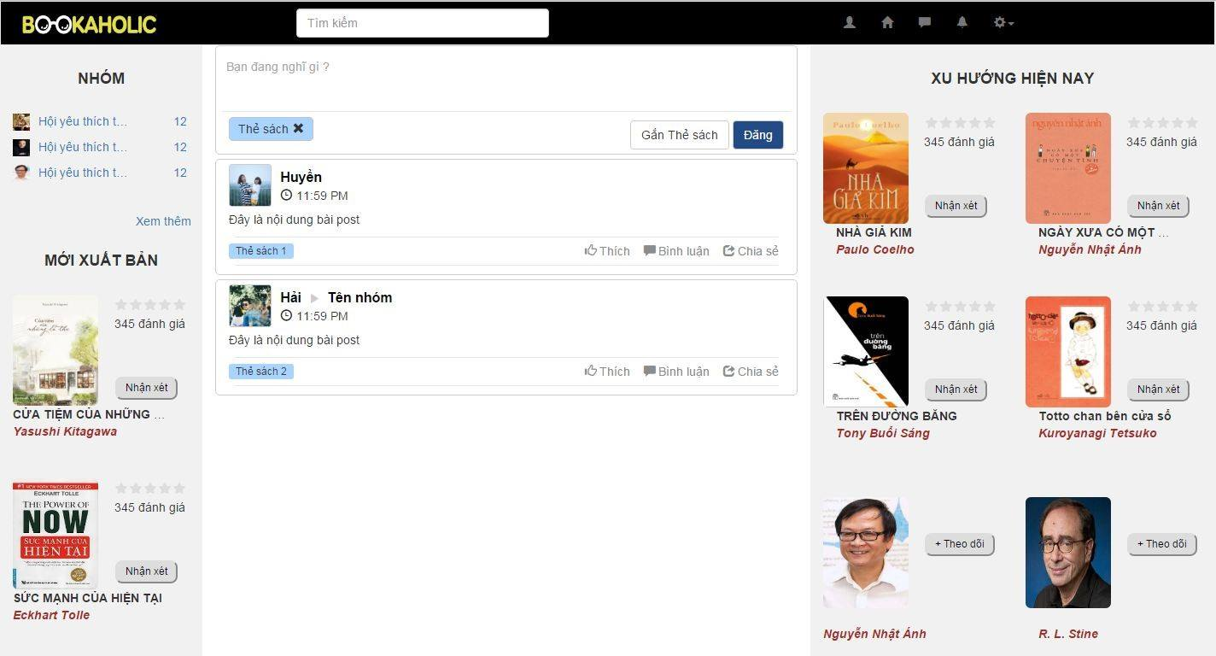

Figure .: Post a recommendation

### Edit caption

To users (includes Reader and Author) want to edit caption of posted recommendation, the users do the steps below:

Step 1: Viewing personal’s recommendation

Step 2: Click “Sửa” hyperlink on angle-down icon at top-right of the post

Step 3: Modifies caption

Step 4: Click “Đăng” button

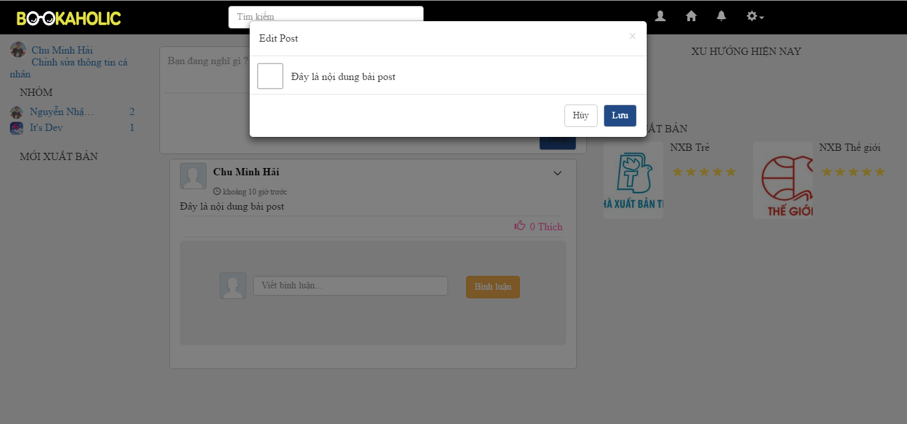

Figure .: Edit caption

### Edit book’s tag

To users (includes Reader and Author) edits book’s tag, the users do the steps below:

Step 1: Viewing personal’s recommendation

Step 2: Click “Sửa” hyperlink on angle-down icon at top-right of the post

Step 3: Modifies book’s tag

Step 4: Click “Đăng” button

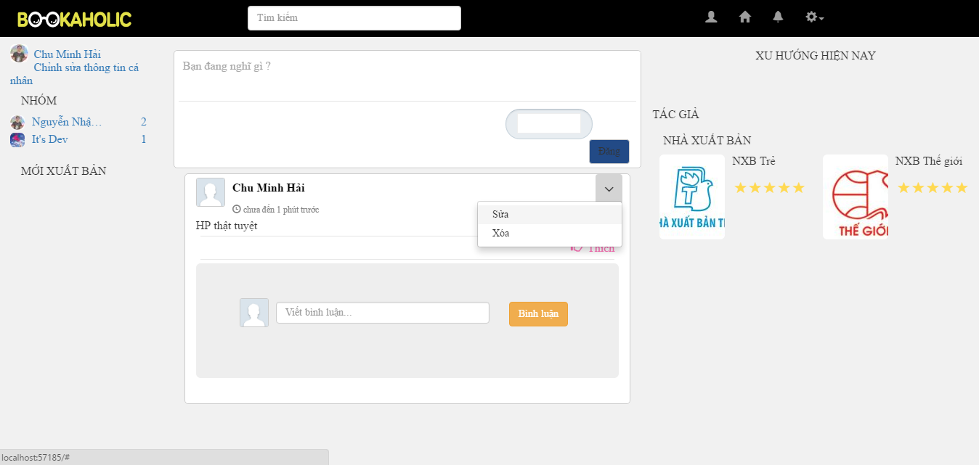

Figure .: Edit book's tag

### Delete post

To users remove a recommendation, the users do the steps below:

Step 1: Viewing personal’s recommendation

Step 2: Click “Xóa” hyperlink on angle-down icon at top-right of the recommendation

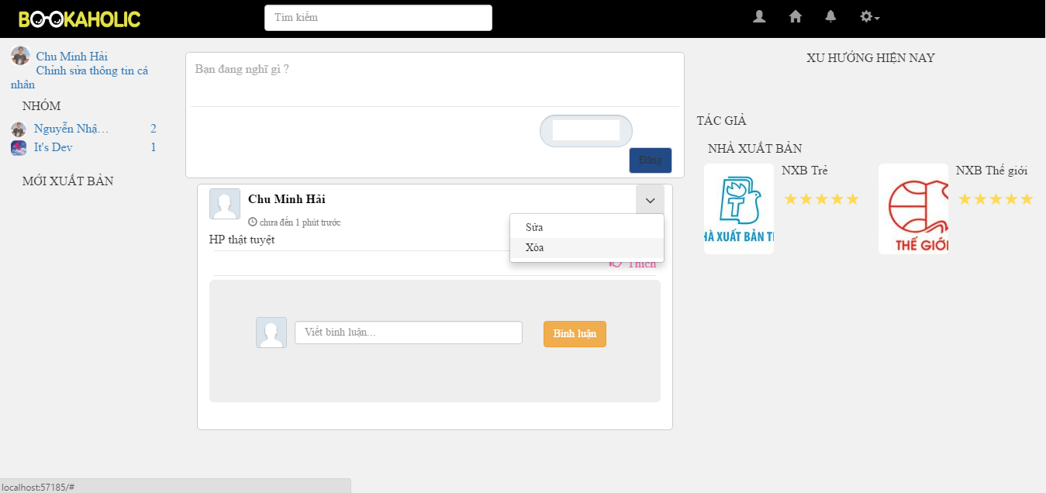

Figure .: Delete recommendation

### Like post

To users like a post, the users do the steps below:

Step 1: Viewing a post

Step 2: Click “Like” button below caption

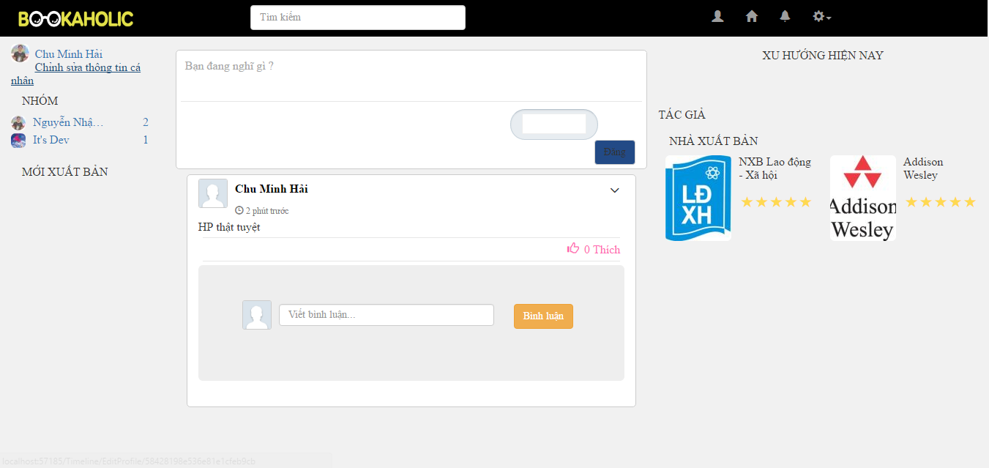

Figure .: Like post

### Unlike post

User to unlike others’ post and their own post, the users do the steps below:

Step 1: User logged in BSN website and post that user liked

Step 2: Viewing a post

Step 3: Click “Like” button below caption



## Comment

### Comment on a post

In a post , user comment on a recommendation/ post, the users do the steps below:

Step 1: User logged in BSN website

Step 2: Click “Viết bình luận” text area below caption

Step 3: Enter a comment

Step 4: Click “Đăng” button

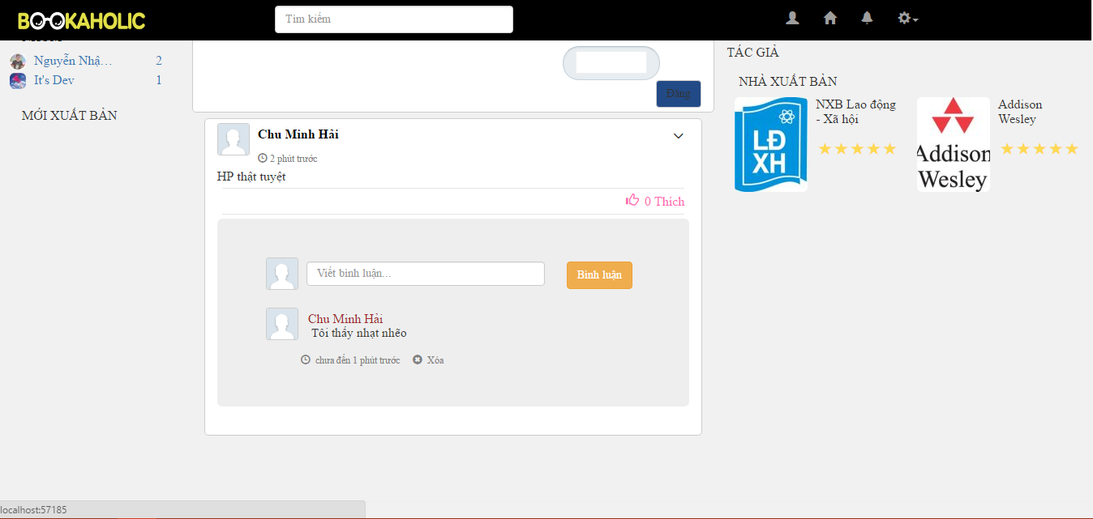

Figure .: Comment on a post

### Delete comment

In comment, users delete a comment, the users do the steps below:

Step 1: User logged in BSN website

Step 2: Click “Xóa” hyperlink on pencil icon at right of comment



Figure .: Delete comment

## Group

### Create a group

To users create a group, the users do the steps below:

Step 1: User logged in BSN website

Step 2: Go to home page

Step 3: Display home page includes:

* Navigation bar
* Side bars
* Posts area

Step 4: Click “Tạo nhóm” button in home page

Step 5: Enter information and click “Tạo” button

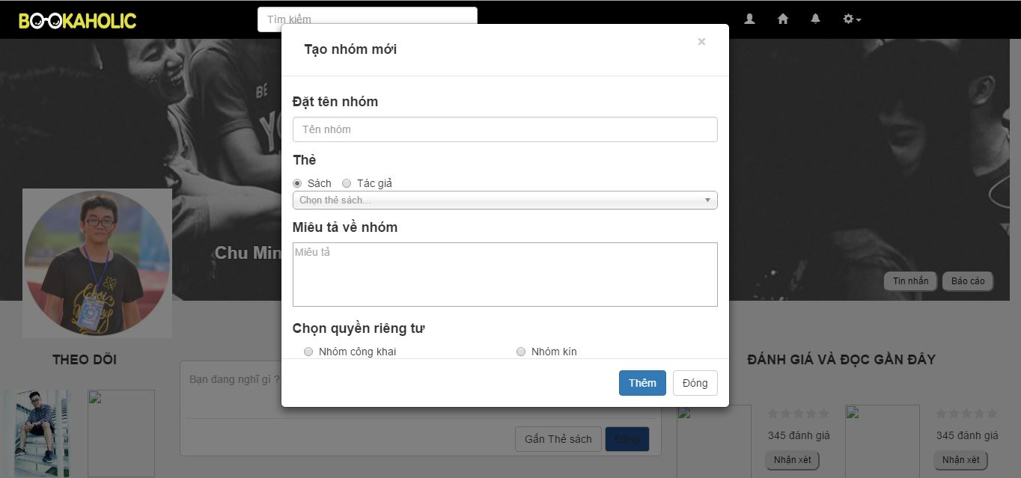

Figure .: Create a group

### Edit group profile

To user to edit group profile, the users do the steps below:

Step 1: User logged in BSN website

Step 2: Go to group page

Step 3: Display group page includes:

* Navigation bar
* Group’s panel
* Side bars
* Posts area

Step 4: Click “Cài đặt” button in home page

Step 5: Enter information and click “Lưu” button

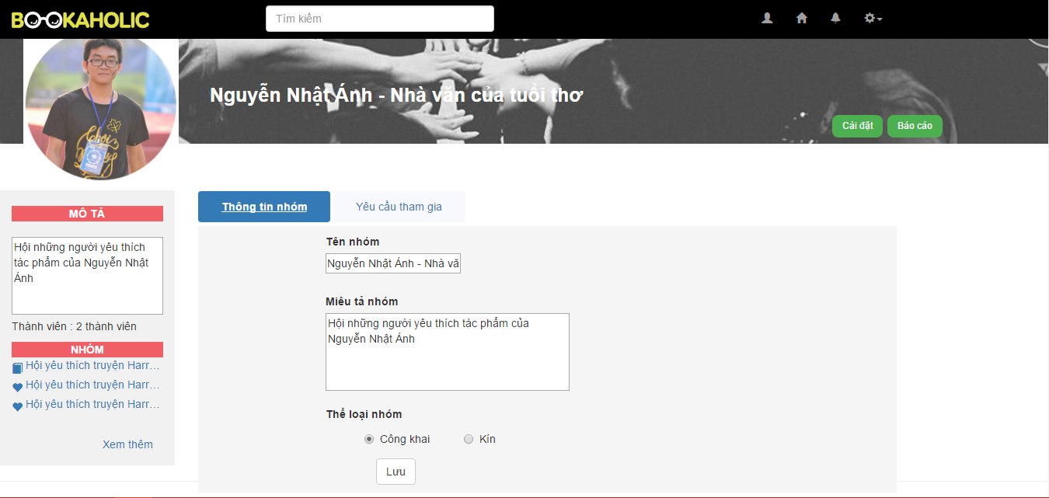

Figure .: Edit group profile

### Add new member by enter account name

To users as an admin of group to add new member by enter account name, do the steps below:

Step 1: User logged in BSN website as admin

Step 2: Go to group page

Step 3: Display group page includes:

* Navigation bar
* Group’s panel
* Side bars
* Posts area

Step 4: Choose an account name

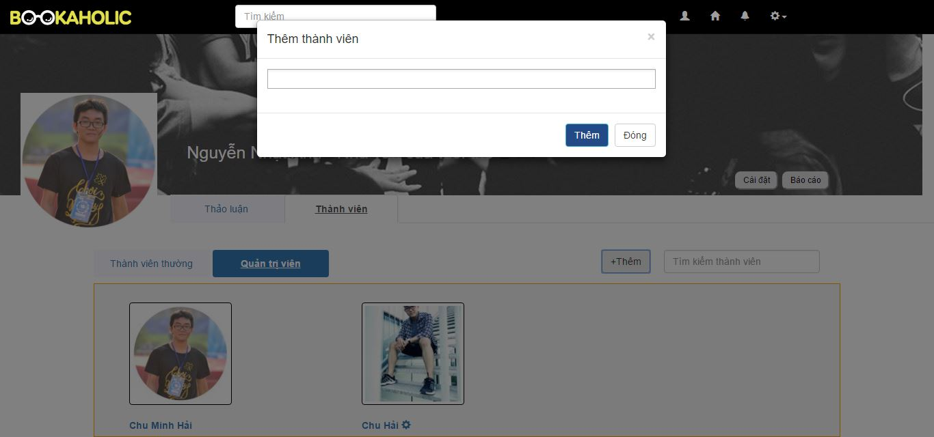

Figure .: Add new member by enter account name

### Add new member by accept join-group request

User as an admin of group to add new member by accept their request, do the steps below:

Step 1: User logged in BSN website as admin

Step 2: Go to group page

Step 3: Display group page includes:

* Navigation bar
* Group’s panel
* Side bars
* Posts area

Step 4: Click “Cài đặt” button, then click “Yêu cầu tham gia” tab

Step 5: Accept one or many request

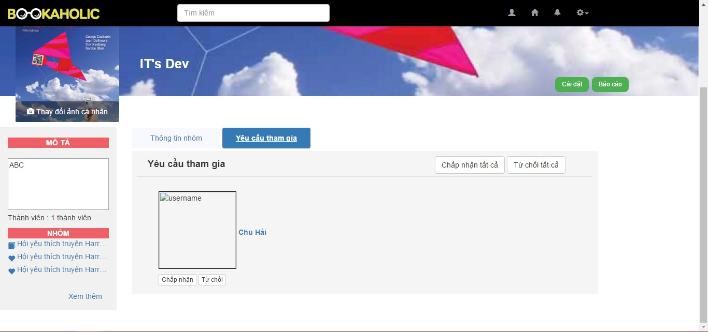

Figure .: Add new member by accept join-group request

### Set another member admin

User as an admin of group to set other be an admin, do the steps below:

Step 1: User logged in BSN website as admin of group

Step 2: Go to group page

Step 3: Display group page includes:

* Navigation bar
* Group’s panel
* Side bars
* Posts area

Step 4: Click “Thêm với tư cách quản lí” hyperlink on dropdown list in config icon in “Thành viên” tab

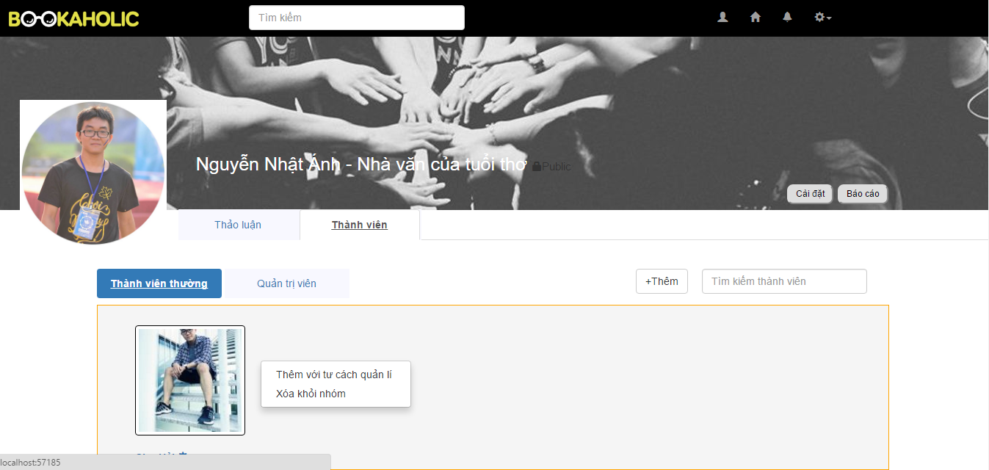

Figure .: Set another member admin

### Edit group’s avatar and cover photo

User as an admin of group edit cover and avatar photo, do the steps below:

Step 1: User logged in BSN website as admin of group

Step 2: Go to group page

Step 3:

* Click to camera icon to edit avatar and cover photo .
* Choose photo

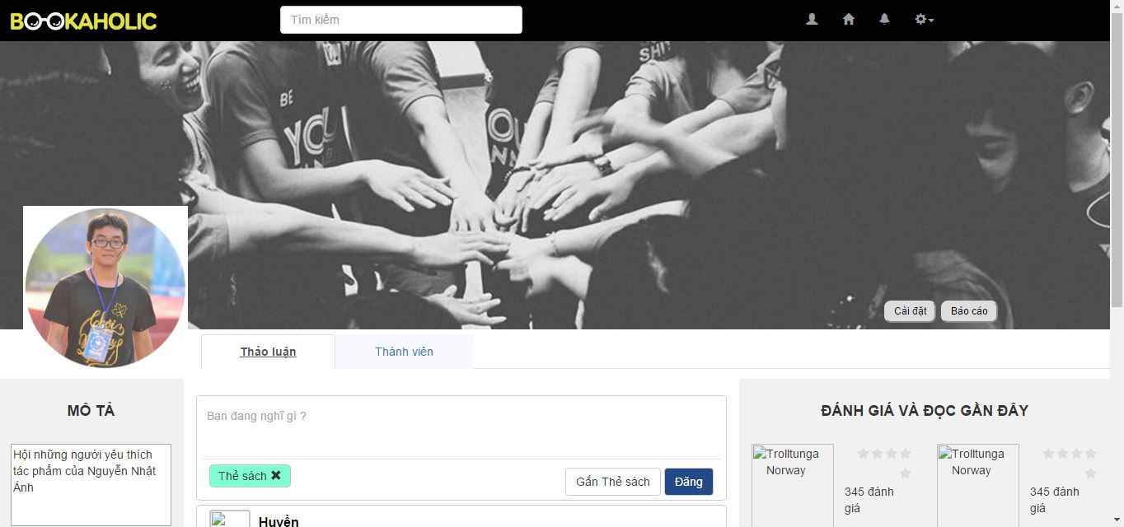

Figure .: Edit group's avatar and cover photo

At step 3 when choose photo :



Figure .: Edit group's avatar and cover photo

### Remove member

User as an admin of group to remove member out of group, do the steps below:

Step 1: User logged in BSN website as admin of group

Step 2: Go to group page

Step 3: Display group page includes:

* Navigation bar
* Group’s panel
* Side bars
* Posts area

Step 4: Click “Xóa khỏi nhóm” hyperlink on dropdown list in config icon in “Thành viên” tab

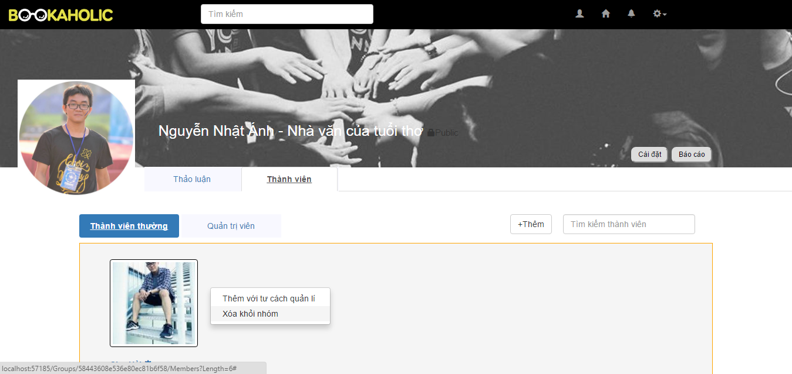

Figure . :Remove member

### Create group post

User create a group, the user do the steps below:

Step 1: User logged in BSN website

Step 2: Click text area and enter a recommendation

Step 3: Choose tag book

Step 4: Click “Đăng” button

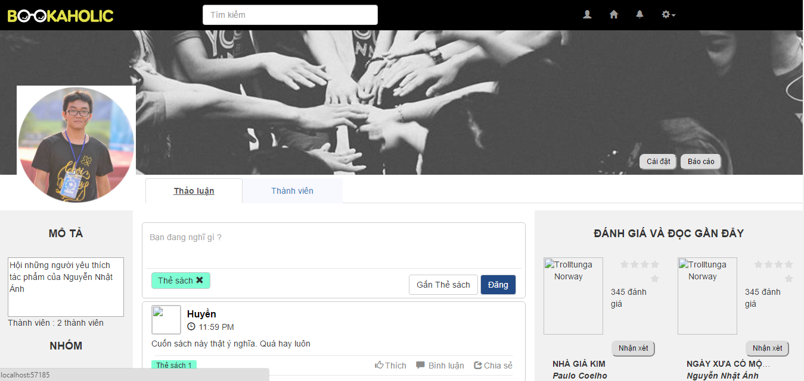

Figure .: Create group post

### Like a group post

User logged in BSN website as admin of group, the user do the steps below:

Step 1: Go to BSN website

Step 2: Create a group or join group

Step 3: Click “Like” button

At the step 3 calculates and displays the total number of likes



Figure .: Like a group post

### Edit group post

Creators post edit group post, **the creator do the steps below:**

Step 1: User logged in BSN website as creator post

Step 2: View post

Step 3: Click “Sửa” on drop down list

Step 4: Edit information

Step 5: Click “Lưu” button

At the step 5 information of group will be updated

### Delete group post

Creators post or admin of group edit group post, the creator do the steps below:

Step 1: User logged in BSN website as admin of group or creators post

Step 2: View post

Step 3: Click “Xóa” on drop down list

### Comment on group post

User comment on a group post, the user do the steps below:

Step 1: User logged in BSN website as member of group

Step 2: View group post

Step 3: Click comment textbox and enter content

Step 4: Click “Đăng” button

### Delete a comment on group post

User delete comment of post, the user do the steps below:

Step 1: User logged in BSN website as creator’s post

Step 2: View group post

Step 3: Click “Xóa” button

At step 3, Comment was deleted

## Book

### Rate a book

User to rate a book, the user do the steps below:

Step 1: User logged in BSN website

Step 2: Enter a book’s page (click name of book on home page, personal page, group page ….)

Step 3: Display a book’s page includes:

* Book’s image
* Book’s information
* Rating stars
* Comment area

Right side bar

Step 4: Click rating stars between 1 – 5 stars to rate this book

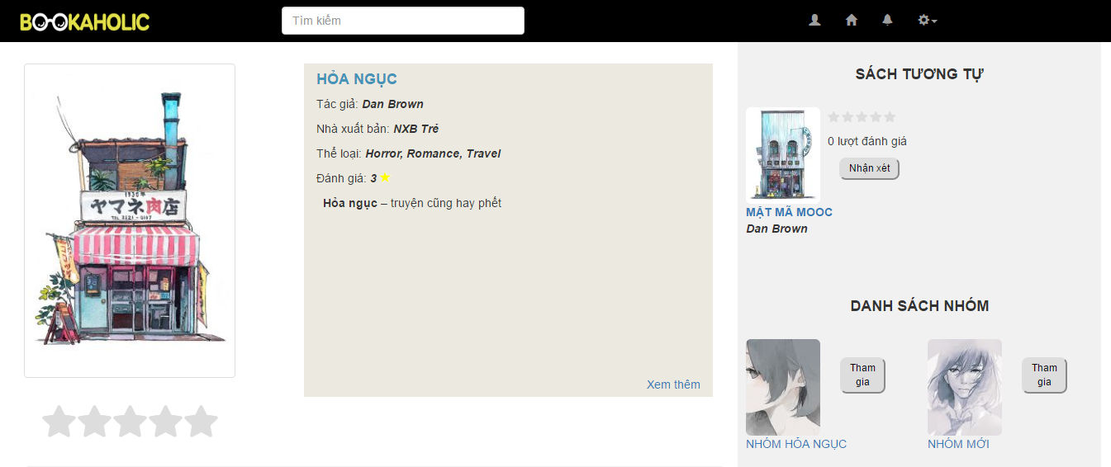

Figure .: Rate a book

### Comment a book

User to comment on a book, the user do the steps below:

Step 1: User logged in BSN website

Step 2: Enter a book’s page (click name of book on home page, personal page, group page ….)

Step 3: Display a book’s page includes:

* Book’s image
* Book’s information
* Rating stars
* Comment area

Right side bar

Step 4: Click on comment textbox and enter a comment then press Enter

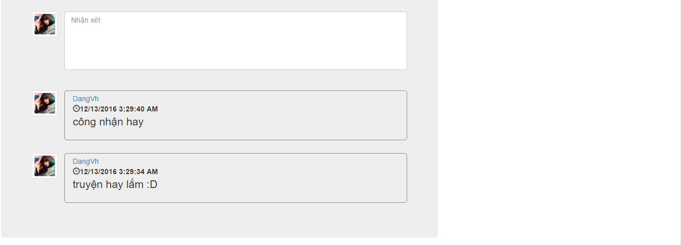

Figure .: Comment a book

### View book detail

User to view book’s details, the user do the steps below:

Step 1: User logged in BSN website

Step 2: Enter a book’s page (click name of book on home page, personal page, group page ….)

Step 3: Display a book’s page includes:

* Book’s image
* Book’s information
* Rating stars
* Comment area

Right side bar

Step 4: Click on “Xem thêm” hyperlink in book’s page

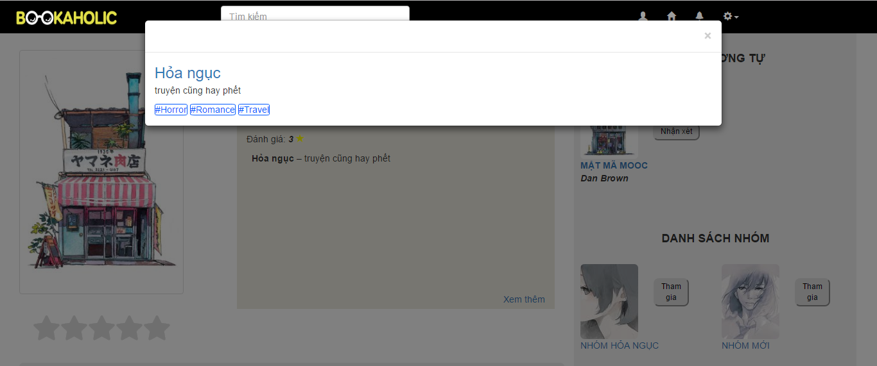

Figure .: View book detail

### View suggested book

User to view suggested books, the user do the steps below:

Step 1: User logged in BSN website

Step 2: Enter a BSN website

Step 3: Display a home page includes:

* Navigation bar
* Side bars with list of groups, suggested books and authors
* Recommendation area

Newsfeed



Figure .: View suggested book

## Interaction

### Follow user account

User can follows the other and get update their actions like: posting, etc., the user do the steps below:

Step 1: User logged in BSN website

Step 2: Go to another user’s personal page

Step 3: Display other’s personal page includes:

* Navigation bar
* Personal panel
* Side bars

Recommendation area

Step 4: Click “Theo dõi” button in other’s personal panel

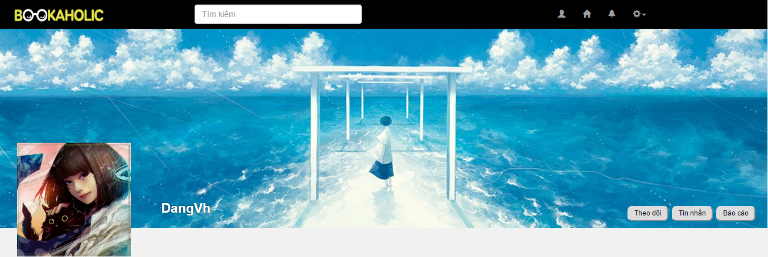

Figure .: Follow user account

### Report user account

User report the other, the user do the steps below:

Step 1: User logged in BSN website

Step 2: Go to another user’s personal page

Step 3: Display other’s personal page includes:

* Navigation bar
* Personal panel
* Side bars

Recommendation area

Step 4: Click “Báo cáo” button in other’s personal panel

Step 5: Choose a reason and click “Gửi” button

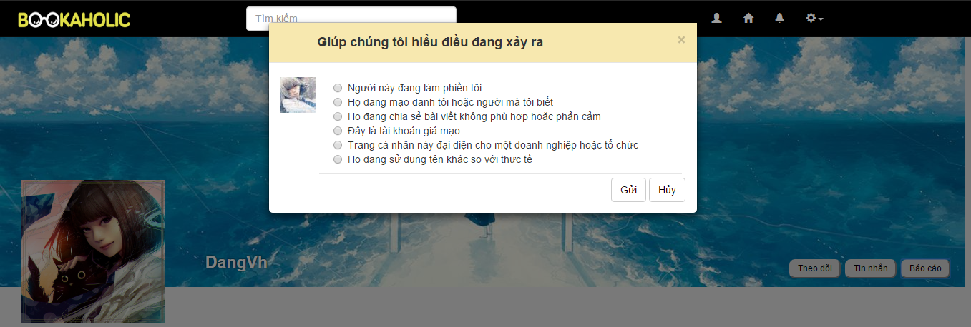

Figure .: Report user account

### Sent join-group request

User send request to join a group, the user do the steps below:

Step 1: User logged in BSN website

Step 2: Go to group page

Step 3: Display group page includes:

* Navigation bar
* Group’s panel
* Side bars

Posts area

Step 4: Click “Tham gia” button in group’s panel

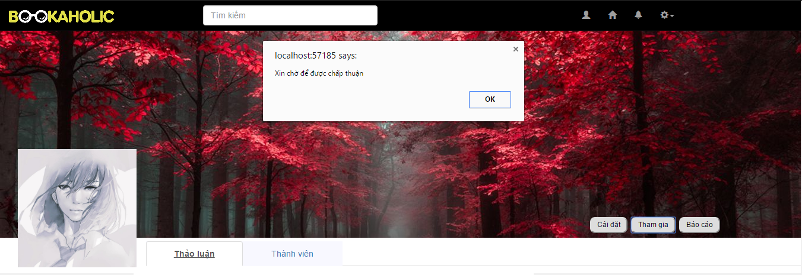

Figure .: Sent join-group request

### Leave a group

User out a group, the user do the steps below:

Step 1: User logged in BSN website

User joined a group

Step 2: Click “Rời nhóm” button in group’s panel

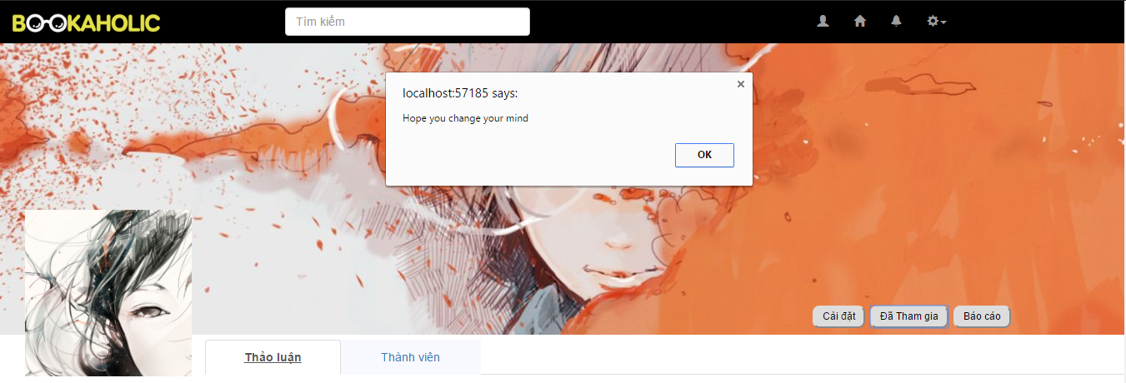

Figure .: Leave a group

### Report a group

User report a group, the user do the steps below:

Step 1: User logged in BSN website

User joined a group

Step 2: View group page

Step 3: Click “Báo cáo” button in group’s panel

Display popup with list of radio button includes:

* List of reasons

Text field to enter another reason

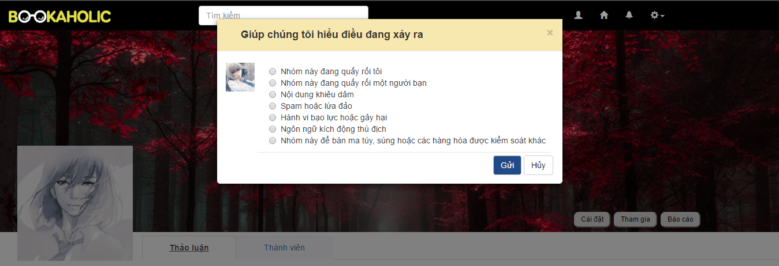

Figure .: Report a group

## Admin

### Login

To login admin account, the users do the steps below:

Step 1: Open browser and enter to the address bar: <http://bookaholic.com/>.

Step 2: Admin enter username and password

Step 3: Click on Login button



Figure .: Login

### User

#### Search user

Admin search user, the admin do the step bellows:

Step 1: Log in as admin

Step 2: Click search textbox

Step 3: Enter name of user

At the step 3: The name of user is displayed

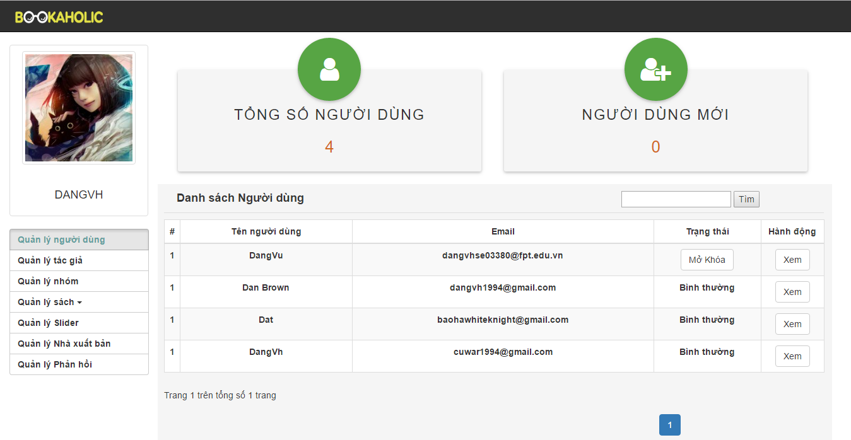

Figure .: Search user

#### Ban user

Admin ban user, the admin do the step bellows:

Step 1: Log in as admin

Step 2: Click ban button

At the step 2, user will be banned



Figure .: Ban user

#### Unban user

Admin unban user, the admin do the step bellows:

Step 1: Log in as admin

Step 2: Click unban button

At the step 2, user will be unbanned



Figure .: Unban user

### Group

#### Ban a group

Admin ban a group, the admin do the step bellows:

Step 1: Go to Admin page, Click on “Quản lý nhóm”.

Step 2: Click ban button

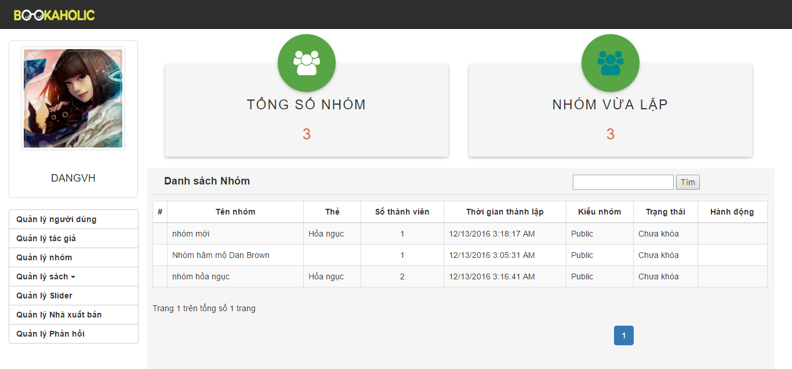

Figure .: Ban a group

#### Unban a group

Admin unban a group, the admin do the step bellows:

Step 1: Go to Admin page, Click on “Quản lý nhóm”.

Step 2: Click unban button



Figure .: Unban group

### Book

#### Add a new book

Admin add new book, the admin do the step bellows:

Step 1: Go to Admin page, Click on “Quản lý sách”.

Step 2: Click “Thêm sách” button

Popup add new book is displayed

Step 3: Input all information of book

Step 4: Click “Thêm” button

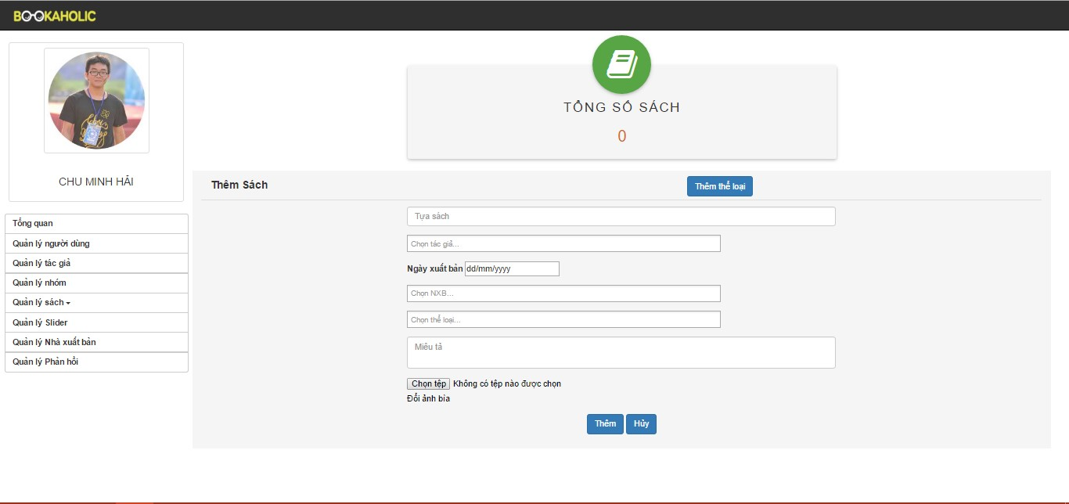

Figure .: Add a new book

#### Add a new category

Admin add new category, the admin do the step bellows:

Step 1: Go to Admin page, Click on “Quản lý sách”.

Step 2: Click “Thêm sách” button

Step 3: Click “Thêm thể loại” button

#### Edit book’s information

Admin edit book’s information, the admin do the step bellows:

Step 1: Go to Admin page, Click on “Quản lý sách”.

Step 2: Click to edit book button

Step 3: Edit information of book

Step 4: Click “Lưu” button

### Sliders

#### Add a new slider

Admin add a new slider, the admin do the step bellows:

Step 1: Go to Admin page, Click on “Quản lý Slider”.

Step 2: Click add slider

Step 3: Input all field to add slider

Step 4: Click “Thêm” button

Slider will be accepted

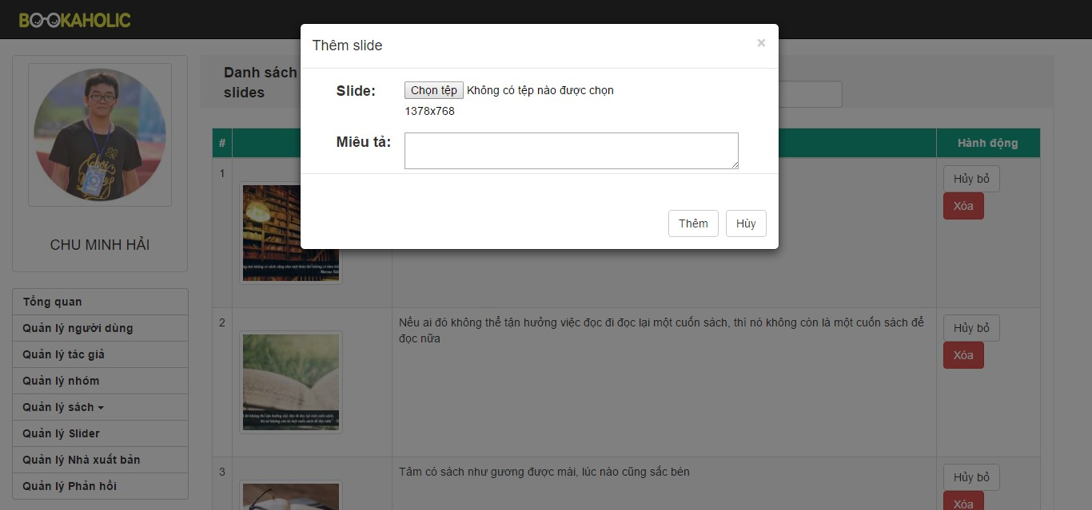

Figure .: Add a new slider

#### Delete a slider

Admin delete a slider, the admin do the step bellows:

Step 1: Go to Admin page, Click on “Quản lý Slider”.

Step 2: Click “Xóa” button

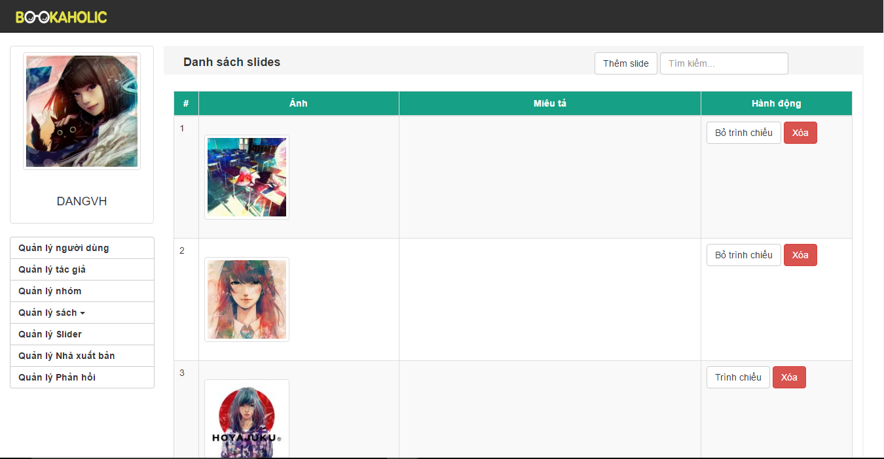

#### Active/de-active a slider

Step 1: Go to Admin page, Click on “Quản lý Slider”.

Step 2: Click “Trình chiếu “ và “Hủy trình chiếu” button



### Publisher

#### Admin add a new publisher

Admin add a new publisher, the admin do the step bellows:

Step 1: Go to Admin page, Click on “Quản lý Quản lý nhà xuất bản”.

Step 2: Click add publisher

Step 3: Input all field to add publisher

Step 4: Click “Thêm” button

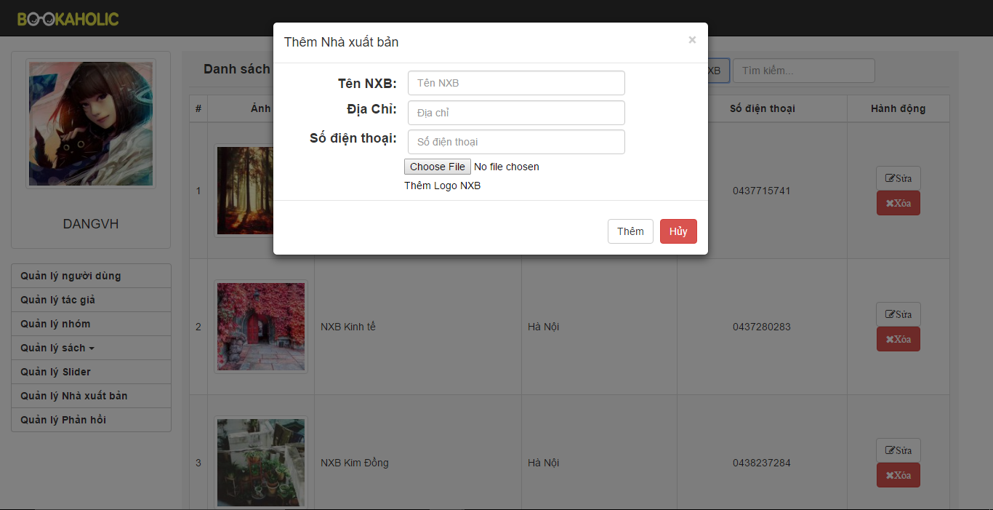

Figure .: Add new new a publisher

#### Edit publisher’s information

Admin edit publisher's information, the admin do the step bellows:

Step 1: Go to Admin page, Click on “Quản lý Quản lý nhà xuất bản”.

Step 2: Click to edit publisher button

Step 3: Edit information of publisher

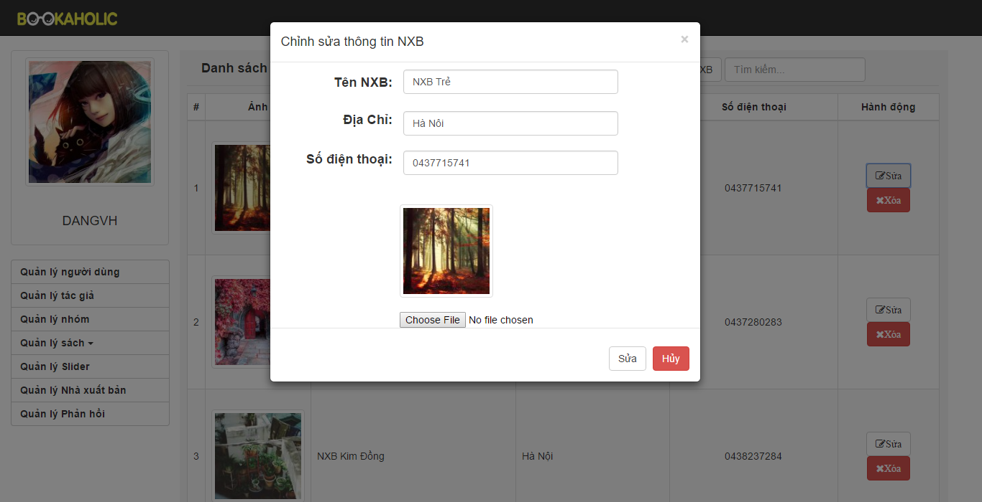

Figure .: Edit publisher's information